Around the Film Industry

Miguel A. Urrutia, Dominic Cortez, Adam Resendez, & Teresita Perez

CIS 3100, Stefan Bund

**Abstract**

*Objective:* To analyze world around the Film Industry such as seeing issues, competition, and overall outlook of the environment. *Method 1:* We used PESTLE that that focuses on the Political, Economic, Social, Technical and Environment. *Method 2:* Five Forces that reaches its competitor substitutes, bargaining power to its suppliers and buyers and threats around the industry. *Method 3:* SWOT Analysis researching the Strength, Weakness, Opportunity, and Threats. *Method 5:* Lastly, referencing eight key points from the textbook that correlate with the Film Industry.

**Method 1**

*Legal and Social*

Film industry faces a growing number of sexual harassment report which started when Harvey Weinstein was accused of sexual harassment back in October 2017.1 Harvey Weinstein is a well-known film producer and during the investigation, it was revealed there had been three decades worth of undisclosed sexual accusations which led to his arrest.1 Weinstein arrest created a social movement called Weinstein effect, in which other actors, directors, and politicians are accused of sexual harassment. In The New York Times they have a list of 71 men who were accused for sexual harassment and have resigned from their respected occupation.2

Producers Guild of America (PGA) are implementing new guidelines to fight against sexual harassment in movie production sets. These are just guidelines meaning it is just an informational reminder to respect each other. However, producers can leave the PGA when they like to and not be bound by the new guidelines.4

*Facts*

USA TODAY created a survey done to a group of 843 women who work in the entertainment industry asking them if they had been in some way a victim of sexual harassment. The result was that 94% of the women surveyed responded with a yes, in having been a victim of sexual harassment. In the survey, the lists show the types of sexual harassment one experiences, unwelcome sexual comments being the top of the list. 3

*Politics*

Trump's border wall and discrimination towards the Latino can lead to fewer Latino moviegoers.5 According to Theatrical Market Statistics, it shows that the second largest group of moviegoers are Hispanics/Latinos and just recently in 2016 the number has gone up.5 Political pressure that is dehumanizing Hispanics, and the lowering the number of Hispanic lead roles. Could eventually discourage Latinos moviegoers, a reduction that will hurt sales.5,6

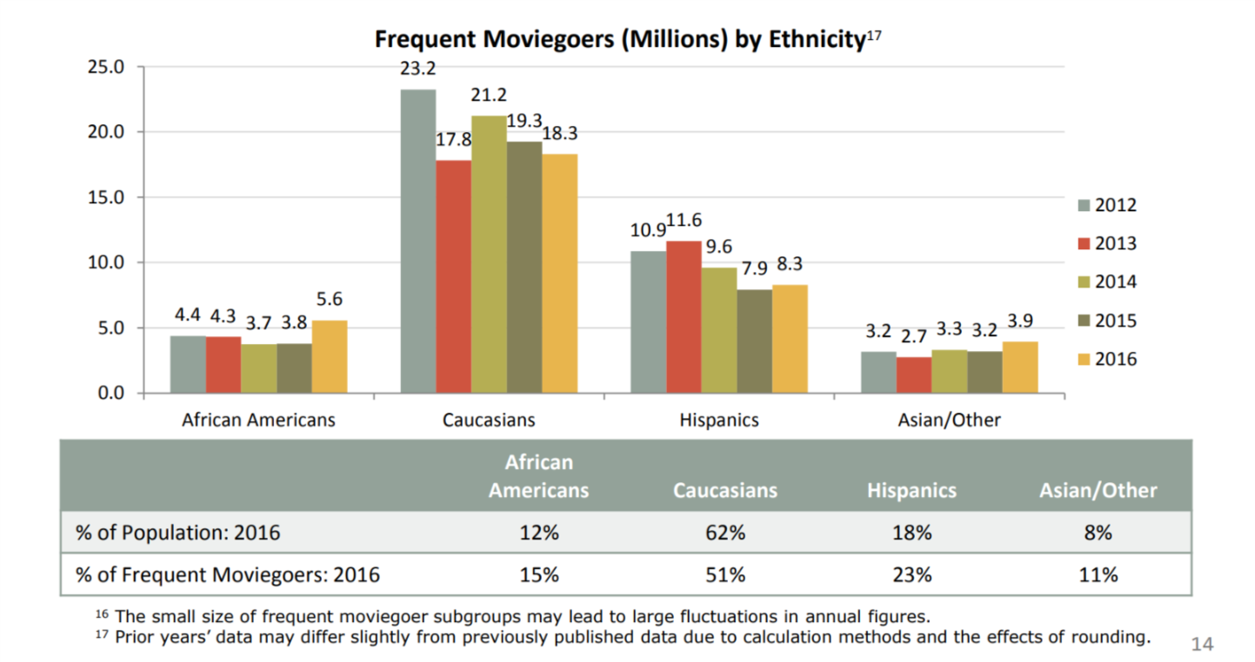7. Moviegoes according Motion Pictures Cinemea, Theatrical Market Statistics

*Environment and Technology*

Colombia University journal page State of the Planet writes on how the movie industry is working on reducing its environmental impacts. Such as reducing Carbon and Green Gas Offset, Waste Diversion, Transportation, Water Use Reduction and Energy Efficiency. Carbon and Green Gas which is created from traveling to movie sites, transporting supplies, power generators, and pyrotechnical equipment. Film Industry companies like 21st Century Fox has contracted a third-party company to help the company stay on track, help improve the reduction of carbon emissions. As well as, PGA implementing guidelines for the movie production. Waste is caused by actor props, backdrops, movie set props, and leftover food. So, companies like Sony Pictures located in Culver City CA have partnered up with the city to donate, instead of throwing it away as waste. Transportation is one of the largest greenhouse gas contributors so companies like CBS Entertainment are beginning to use hybrid vehicles and completely electric vehicles to reduce carbon emissions. Water is being conserved by industries like NBC Universal that are recycling rainwater and installing water filtration systems to reduce plastic waste. Energy efficiency like Warner Brother Studios which have installed solar roofs that are helping them run their studio. 8

*Economic*

Money is being a concern in the film industry as there is not much money that comes in from movie rentals and sales. Film industry is focusing more on blockbuster production that will have more life value opposed to smaller films. Example Avengers movies have a large return value as there is products that can be sold to the fans from costumes, toys, collectibles and other items. Small films are being sponsored by online network companies like Netflix and Amazon due to their unlimited budget from subscription. A new trend that is coming up is the China investing some of the cost of production money, in exchange for having their Chinese Actor an Actresses to have a leading role.9

**Method 2:**

Objective:

First task was to analyze the 10k financial reports of some of the major companies in the industry and compile the information to see if there was some sort of trending activity that’s happening in the industry. The second task was to construct a “Five forces” graph and do the industry analysis. Lastly was to see the distribution of wealth compared to the geographic location of the business.

Abstract:

First was finding 10k reports online for Netflix, Comcast, Viacom; these three were chosen to represent the industry since they have an established presence in the industry.

After finding the 10k reports I went through each finding the area they’ve specifically labeled as financial data. For Comcast and Viacom both have clearly labeled 10k reports, however Netflix only reported a compiled balance sheet with the most up to date information. After reviewing all of the balance sheets and taking down their revenue and expenses I branched over to the risk factors that each company was labeling in their financial reporting. From this data I was able to compose a Five Forces analysis of the industry and contribute that to the group.

*Results*

After putting together the 10k reports and analyzing the individual firms we were able to come to the follow conclusions. The industry is overwhelming aware of the risk of consumer power. Each firm was scared of losing consumer base to political, environmental, and competitive elements. Their main prerogative seemed to address that they were doing everything in their power to remain on top of trends, stay in good political light, and remain cost efficient for consumers. This was one trend that arrived at each of the companies making 5-7% increase in revenue this past year. Another risk factor each of them listed was that technology was creating too many alternatives to the industry and that it could eventually cause a loss of viewership or subscribers. For Viacom, these were the only two risks listed, however Netflix and Comcast both shared a third risk was that the viewership/subscribers would decline because of inability to provide service to their growing consumer base. The operating expenses for each firm chosen had gone up 9%-11% according to their 2017 10k reporting’s.

The last portion of the was to analyze the top five geographic locations of these business and to see where the wealth distribution was. We discovered on the census website that there was a listing of earnings done by the census based on the geographical location already. We took this data put it into excel and graphed it to produce the distribution of wealth based off of number of companies in the geographic area.

Profitability decreases as competition increases. Three of the five forces relate to industry participants The other two relate to the vertical components – suppliers and consumers.

1. How competitive is the industry as it stands Comcast, Netflix, Viacom
2. How easy is it for new players to enter the industry – Netflix , Viacom
3. How possible is it for new product to disrupt chain. – Netflix, Comcast,
4. How accessible are the suppliers of the raw material - Viacom
5. Consumer has bargaining power? erodes profitability. Netflix, Comcast

as defined by Porter’s 5 forces.10

1. Comcast, Netflix, and Viacom all listed amongst their risks in their 10k that the competitiveness in the industry was a main concern.
2. Netflix, and Viacom specifically worried about entry to the industry stems from multiple directions.
3. Netflix worried about piracy and other new entries to the streaming world. Amazon Hulu etc. Comcast worried that new providers and mobile carriers will start stealing customers.
4. Viacom – not necessarily worried about raw materials, but they’re first listed risk and concern is to stay ahead of trends and maintain attractive content. Netflix is worried they might have too many subscribers which their platform might suffer technical issues.
5. Netflix is worried about losing subscribers, Worried about becoming too large to afford their audience/ rising prices of technology and consumer demand creates for hard field.

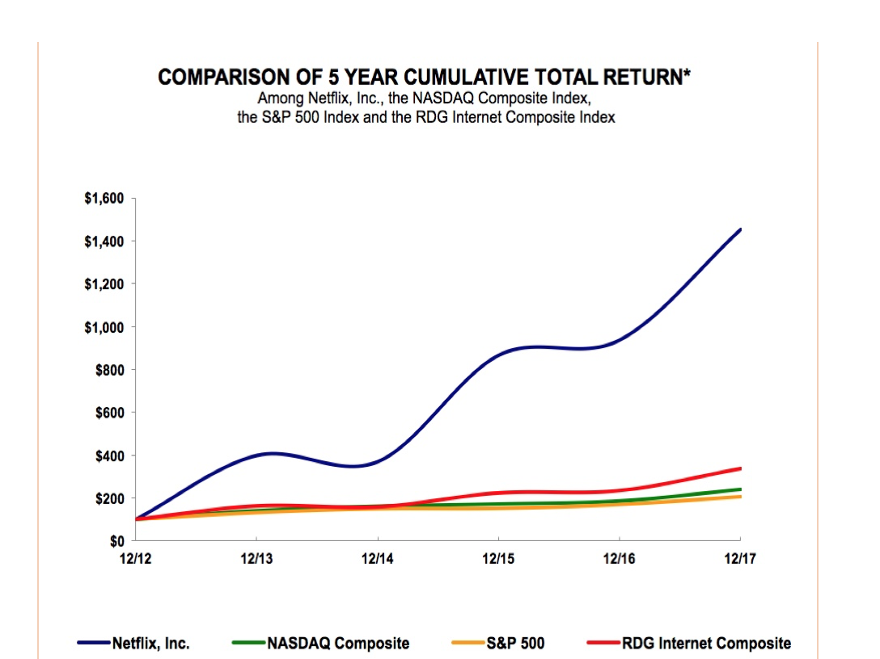

Total Revenue of Industry distributed across geographic location

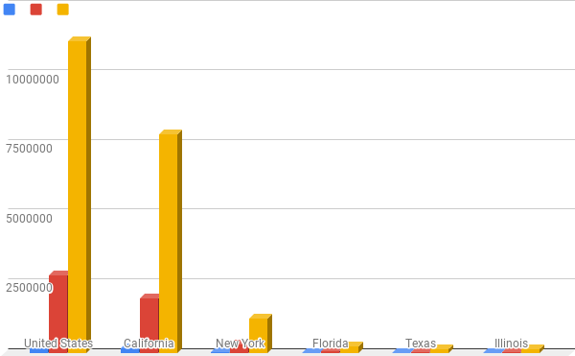

**Method 3:**

*Strengths*

The top ten Film Production Establishments are: Warner Bros., Sony Pictures Motion Picture Group, Walt Disney Studios, Universal Pictures, 20th Century Fox, Paramount Pictures, Lionsgate Films, The Weinstein Company, Metro-Goldwyn-Mayer Studios and DreamWorks Pictures. These companies are dominant in the motion picture production. They have created strong recognizable brands using large capital which facilitate fast film production. Due to their combined monopoly, entry for smaller companies to join the industry is incredibly difficult. The revenue gained from the motion pictures is significant. This revenue is comprised of theaters box office sales. digital downloads, DVD sales, and content licensing. Furthermore, as a low cost form of entertainment, movies create an advantage to the production companies due to their profitability during economic booms or economic recessions. 11,12

*Weakness*

Operation costs require large amounts of capital. Frequently, various permits are required when doing a motion picture production. For example, permits are required for employing minors, filming in highways, freeways, beaches or parks, using drones, and the usage animals. Also, film production companies heavily rely on advertising which further adds to the marketing costs. Lastly, film production companies often employ union workers which adds additional operation costs with increased labor costs. 14,13

*Opportunities*

There is always opportunity’s for new film to be created but to truly grow, expand their brand and increase production revenue is by Globalization. Having international growth in different countries is an opportunity many production companies need to take. There is an opportunity of growth by innovation due to the increase technological advances. Currently, watching film has become easier by streaming and accessibility; therefore, long-term distribution agreements can serve as a mechanism for film production companies to control the markets. 11

*Threats*

Competition is one of the biggest challenge production companies face. These include other large motion picture producers, streaming company’s such as Netflix, global competitors, cable networks, etc. This is compounded by the fact that all the production companies have the same target audiences. Films must be meticulously released to limit overlaps of release dates of movies of similar content or genres between major competitor release dates. Additionally, an increasing threat to film production companies is digital piracy. Companies have begun to employ expensive technology to combat piracy to minimize the potential loss in revenue. Although these technologies have slowed the increase in piracy, they have yet to successfully deter the illegal digital piracy. 12

**Method 4:**

*Knowledge Society*

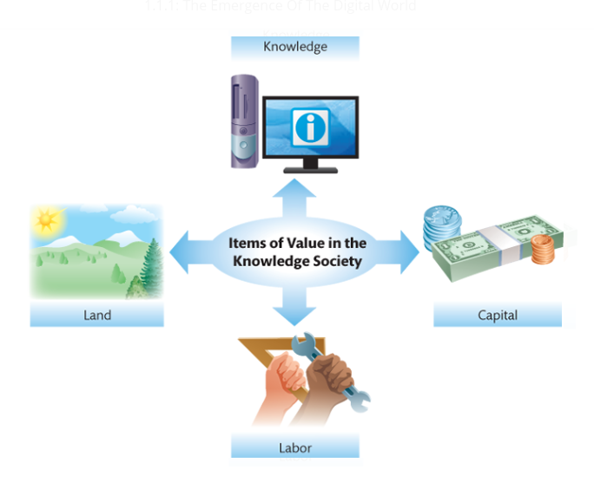

In 1959, a man named Peter Drucker predicted that information and information systems would become increasingly important, and at that point, he coined the term [knowledge](https://etext.pearson.com/eps/pearson-reader/api/item/28eb7558-73a3-4aea-b086-6aea15a960af/1/file/valacich_schneider-ist-8e_eT2_v1/OPS/xhtml/glossary.xhtml) worker. Drucker also predicted that along with the growth in the importance of knowledge workers, a knowledge society would develop.15 This diagram in the textbook shows what different items are important to the “knowledge society” that Drucker predicted half a century ago. In relation to the movie industry, all of these items are essential when it comes to the production of a movie. Land is key when filming a movie because it is where the cast and crew will spend months on end working to make their product- whether it be a movie lot that the company already owns or an entirely new scenery that they have to pay in order to use. In our society today, many would consider capital to be the blood of any industry because of the power that it holds. Capital can give a firm a competitive advantage when it comes to producing movies because that can be money invested in getting the best actors, the correct equipment, correct costumes, or making sure that they have the best people and software to making the CGI look as realistic as possible. Along with these people that are working in front or behind the camera or working behind the computer, there are those that are working tirelessly to build the sets that we as the audience sees on the big screen or even those that have to move around the heavy equipment safely from location to location. The labor force is something that is not usually the first thing to pop into our minds when we think of movie production, yet it is still a crucial aspect that cannot be overlooked. The last aspect that is a key player in a knowledge society is, knowledge. Although knowledge is a broad spectrum, we will look at the knowledge needed to handle the hardware and software that a firm relies on to function. In movie production, extensive knowledge of the equipment can be used to the competitive advantage of a company when making a movie because this can allow for the most creative ways to get a scene shot or enhance the special effects used to impress the audience. Having all of these aspects of a knowledge society come together in the most effective method possible will ultimately decide if a movie will be a commercial or critical success.

*Globalization*

Globalization is a process that is taken into account when making movies because of the prospective financial success that can be earned if the movie is selling in theaters across the globe. A modern-day example that benefited as a result of globalization is the recent release of “Bumblebee”. The film made $124,253,188 domestically; while a sizeable amount of capital this is 11 million dollars short of its budget.16 Luckily, because of the process of globalization, “Bumblebee” was able to rake in an extra $331,000,000 and surpass its original budget.16 Globalization also benefits more than just the big production companies that make the many hits pay to see in theaters. Any streaming service- whether it be Netflix, Hulu, or Amazon Video- is affected by globalization because their services are available to almost every country in the world. “This is made possible by the by falling transportation and telecommunication costs.”15 Whether or not a production company decides to utilize globalization will determine their future as a firm within the industry.

*Technical Competency*

Having personnel that not only simply know how to operate the hardware and software of a business, but to do it efficiently can put a firm at the top of the business.

*Five IT Megatrends*

There are five IT megatrends that have developed as a result of the development in web technologies that are influencing individuals, organizations, and society as a whole.15

1. **Mobile:** With this new level of mobility thanks to the innovations with smart devices, movies can now be viewed anywhere instead of having to go to the theaters. This allows for a larger amount viewers to watch the movie whether they want to see it in the comfort of their own home, during their breaks in between work, or even while they’re waiting in line for their cup of coffee. Smart devices allowing the viewing of movies to be ubiquitous has gained companies not only a growth in capital gain, but in cultural relevance as well.
2. **Social Media:** Social media and the topics discussed trending within it have almost become impossible to avoid. Streaming services such as Netflix and Hulu have gained more popularity through the use of social media as people begin to create buzz for its products. This trend can be particularly seen most recently with the Netflix original “Bird Box”. The amount of people talking about the movie was astounding in the initial weeks after its release that there was an internet trend in which millions of people participated. This increase in recognition can drastically affect the stock prices of these companies and in order to maintain their level of popularity, these services must keep creating more content for its consumers to enjoy and spread word about.
3. **The Internet of Things:**  A network of a broad range of physical objects that automatically share data over the Internet.15 This can apply to almost everything electronic in our lives today- especially our smartphones. Whenever we view something on our phone, this data is then sent to companies that can then produce ads for various things that peak out interest. This can apply to moviegoers because if Instagram, for instance, has noticed that a user has “liked” posts related to superheroes, action, or drama, this information can then be used to tailor advertisements for movies related to these genres. However, this innovation in technology increases concern when it comes to digital privacy.
4. **Cloud Computing:** Much of the functionality previously offered by applications installed on each individual computer is offered by applications “in the cloud,” accessed via a web browser.15 This is useful for moviegoers because the information of showtimes and movie reviews are now readily available in an instant.
5. **Big Data:** Coming with the increase in technology development was the amount of data that could be stored. This means that now more than ever we can store ridiculously large amounts of data online- one being movies. This can be a good or bad thing for production companies because they can now have their movies online digitally. This allows for more people to view their movie because it is a cheaper alternative than buying a movie ticket that is far more expensive.

*Intellectual Property*

Any creations of the mind that have commercial value is considered Intellectual Property.15 Movies are considered Intellectual Property because other people will pay in order to consume/watch it. However, anyone can find said property online and pirate it instead of having to actually pay for it. If this were to occur, this can hurt a company’s profit if enough people follow this route because why pay for a movie at all if you can get it for free? This causes many legal and ethical questions as to who is correct when it comes to these issues. These technological developments are a double-edged sword that needs to be used carefully.

*Business Competency*

People that know how to deal with and manage people more than just how to operate the equipment are crucial to a firm’s workforce. Hollywood executives can be rather picky people and have a large say in how a movie should be made, but a worker that knows how to handle them can mean more time or money for the project’s completion.

*Information Systems for Competitive Advantage*

Many movie theatres offer rewards programs for those who decide to sign up. This is important for membership retention because there are various special offers that these theatres give for signing up for these programs. For instance, the popular theatre chain Edwards Cinema gives its rewards members birthday gifts and this is made possible with the use of Information Systems for keeping track of such information. The efficiency of these Information Systems can help theatres such as Edwards gain a competitive advantage over, say, Harkins because they used this not only collected this Information, but also used it in a way that will attract more customers to their doors.

*Information Technology*

Information Technology is important when it comes to the development of movies. The hardware that is used in this process are the computers used to edit and store the footage of the movie while the software is the different programs used to edit the footage together or generate CGI. The telecommunication networks that are used in the film industry can be seen whenever a movie is watched online through a streaming service because our computers must connect to the networks in order for it to play.

**CITATION**

1. Kantor J, Twohey M. Harvey Weinstein Paid Off Sexual Harassment Accusers for Decades. The New York Times. https://www.nytimes.com/2017/10/05/us/harvey-weinstein-harassment-allegations.html. Published October 5, 2017. Accessed February 1, 2019.
2. Almukhtar S, Gold M, Buchanan L. After Weinstein: 71 Men Accused of Sexual Misconduct and Their Fall From Power. The New York Times. https://www.nytimes.com/interactive/2017/11/10/us/men-accused-sexual-misconduct-weinstein.html. Published November 11, 2017. Accessed February 1, 2019.
3. Puente M, Kelly C. How common is sexual misconduct in Hollywood? USA Today. https://www.usatoday.com/story/life/people/2018/02/20/how-common-sexual-misconduct-hollywood/1083964001/. Published February 23, 2018. Accessed February 1, 2019.
4. Margolis Z. Guidelines are a start, but sexual harassment in the film industry is not going away soon. The Guardian. https://www.theguardian.com/film/2018/jan/26/sexual-harassment-film-industry-producers-guild-of-america. Published January 26, 2018. Accessed February 1, 2019.
5. Sanchez F. What's Hollywood got against Latinos? CNN. https://www.cnn.com/2017/04/03/opinions/latinos-hollywood-sanchez/index.html. Published April 3, 2017. Accessed February 1, 2019.
6. Esai Morales On Latinos, Hollywood and Trump. NBCNews.com. https://www.nbcnews.com/news/latino/esai-morales-latinos-hollywood-trump-n426866. Accessed February 1, 2019.
7. Dodd CJ. Theatrical Market Statistics. 2016.
8. Cut! How the Entertainment Industry is Reducing Environmental Impacts. State of the Planet. https://blogs.ei.columbia.edu/2018/03/29/entertainment-industry-sustainability/. Published March 29, 2018. Accessed February 1, 2019.
9. Arnold A. Is there any money left to be made in the movies? ABC News. https://www.abc.net.au/news/2017-02-25/economics-of-movie-making/8292352. Published February 26, 2017. Accessed February 1, 2019.
10. Kenton W. Porter's 5 Forces. Investopedia. https://www.investopedia.com/terms/p/porter.asp. Published December 13, 2018. Accessed February 1, 2019.
11. Film Production Company SWOT Analysis.<http://www.thefinanceresource.com/swot-analysis/film-production-company-swot-analysis.aspx>. Accessed February 1, 2019
12. The Top 10 Movie Production Companies of All Time.<https://reelrundown.com/film-industry/Top-10-Movie-Production-Companies>. Accessed February 2, 2019
13. Entertainment Industry Associations, Guilds, and Unions.<http://film.ca.gov/production/associations-guilds/>. Accessed February 3, 2019
14. Entertainment Work Permits – Employment of Minors as Child Actors.<http://film.ca.gov/production/work-permits/>. Accessed February 3, 2019
15. Valacich J. Information Systems Today Mymislab With Pearson Etext Access Card Managing in a Digital World. Pearson College Div; 2015.
16. Bumblebee (2018). Box Office Mojo. <https://www.boxofficemojo.com/movies/?id=transformers6.htm>. Accessed February 3, 2019.